A Course File
On
FULL STACK WEB DEVELOPMENT LAB
(III- B. Tech. – II– Semester)
Submitted to
DEPARTMENT OF COMPUTER SCIENCE& ENGINEERING
By
Mr. T.NagaRaju
(Asst Professor, Dept. of CSE)
and
Mr.Y.Bharadwaj
(Asst Professor, Dept. of CSE)
and
Mrs. A.Mahalakshmi
(Asst Professor, Dept. of CSE)


CMR INSTITUTE OF TECHNOLOGY
Kandlakoya(V), Medchal Road, Hyderabad – 501 401
Ph. No. 08418-222042, 22106 Fax No. 08418-222106
(2020-21)

2 CONTENTS

Sl. No. | Particulars | Page No.
1 | Syllabus | 2
2 | Student Entry Behavior or Pre-requisites | 5
3 | Course Objectives | 6
4 | Course Outcomes | 7
5 | Mapping of Course with PEOs-PSOs-POs | 8
6 | Mapping Of Course Outcomes with PEOs | 11
7 | Mapping Of Course Outcomes with PSOs | 12
8 | Mapping Of Course Outcomes with POs | 13
9 | Direct Course Assessment | 14
10 | Indirect Course Assessment | 15
11 | Overall Course Assessment and Attainment level | 17
12 | Pi diagrams, Bar charts, Histograms for representing results | 18
13 | Lesson/Course Plan | 19
14 | Programs | 23

FULL STACK WEB DEVELOPMENT LAB

III-B.Tech.-II-Sem. L T P C

Subject Code: CS-PCC-32 - - 2 1
Course Outcomes: Upon completion of the course, the student will be able to
1.illustrate implementation procedure of full stack web development
CO – PO Mapping
POs | PO4 | PO5 | PO6 | PO8
CO1 | 3 | 3 | 3 | 3
CO2 | 3 | 3 | 3 | 3
CO3 | 3 | 3 | 3 | 3
CO4 | 3 | 3 | 3 | 3
CO5 | 3 | 3 | 3 | 3
3-Strong; 2-Medium; -Weak

2.demonstrate HTML5, CSS5 scripting languages and Github
3.make use of scripting languages in web development
4.develop web applications using AJAX
5.build real time applications using full stack web development

List of Experiments
- Write code in HTML5 to develop simple webpage.
- Write CSS5 & HTML5 Code to show Dropdown Menu.
- Write HTML5, CSS and Javscript code to Create one-page website having different menu items.
- Write a program in CSS to show your city with building and movingcars.
- Write a program to validate web form using javascript.
- Write jquery code to show websiteslider.
- Show version control in Github.
- Write a program in javascript to Create a user login system.
- Create a website showing jquery slider.
- Write a program to show user details using HTML, CSS & AJAX
- Write a program to display options in a search engine using Ajax.

Micro-Projects: Student must submit a report on one of the following Micro–Projects before commencement of second internal examination.
- Develop Project MyNote - A HTML5 App
- Develop a Bookstore application by using HTML5, CSS, jquery in Github
- Develop a shopping cart application by using HTML5, CSS, jquery in Github
- Develop an e-learning system using HTML5, CSS, jquery in Github
- Build a personal portfolio webpage using HTML5, CSS, jquery.
- Develop google.com Search result page using HTML5, CSS, jquery & Ajax
- Develop a webpage to display solar system using HTML5, CSS, jquery & Ajax
- Build Tajmahal using CSS.
- Build a Real-Time Markdown Editor with Node.js
- Develop an User model covering, Registration, Email verification(send an email), Login (with remember me)
- Develop Chess Game using HTML5, CSS, jquery & Ajax
Reference: 1. Full Stack Web Development Lab Manual, Department of CSE, CMRIT, Hyd.
Student Entry Behavior or Pre-requisites

- Students should have basic knowledge on HTML and Css
- Students should have basic knowledge on C and Java programming.
- Student should have knowledge on oops and software engineering concepts
These prerequisites are taken by the students during the first two years. However during the initial sessions the topics are reviewed.

1.Course Outcomes

Course Outcome | Course Outcome Statements
CO - 1 | Develop static web pages with HTML & dynamic web pages with HTML, JavaScript & CSS
CO – 2 | Develop Web application using php
CO – 3 | Create XML documents as database
CO – 4 | Create Web application using servlet with Tomcat server
CO – 5 | Create Web application using jsp with Tomcat server
CO - 6 | Design and develop 3 tier applications and various web components and Database accessing with JDBC Concepts

- Mapping of Course with PEOs-PSOs-POs

(Only Ticking)

Program Educational Objectives (PEOs)

Sl. No. | PEOs Name | Program Education Objective Statements
1 | PEO - 1 | Impart profound knowledge in humanities and basic sciences along with core engineering concepts for practical understanding & project development.[PO’s: 1,2,3,4,5,7,8,9,10,11 and 12] [PSO’s: 1 and 2]
2 | PEO – 2 | Enrich analytical skills and Industry-based modern technical skills in core and interdisciplinary areas for accomplishing research, higher education, entrepreneurship and to succeed in various engineering positions globally. [PO’s: 1,2,3,4,5,6,7,8,9,10 and 12] [PSO’s: 1, 2 and 3]
3 | PEO – 3 | Infuse life-long learning, professional ethics, responsibilities and adaptation to innovation along with effective communication skills with a sense of social awareness. [PO’s: 1,2,3,4,5,6,7,8,9,10,11 and 12] [PSO’s: 2 and 3]

Program Specific Objectives (PSOs)

Sl. No. | PSOs Name | Program Specific Objective Statements
1 | PSO - 1 | Use mathematical abstractions and Algorithmic design along with open source programming tools to solve complexities involved in efficient programming.[PO:1,2,3,4 and 5] & [PEO:1 and 2]
2 | PSO – 2 | Ensure programming & documentation skills for each individual student in relevant subjects i.e., C, C⁺⁺, Java, DBMS, Web Technologies (Development), Linux, Data Warehousing & Data Mining and on Testing Tools.[PO:1,2,3,4,5,10 and 11] & [PEO:1,2 and 3]
3 | PSO – 3 | Ensure employability and career development skills through Industry oriented mini & major projects, internship, industry visits, seminars and workshops. [PO:6,7,8,9,10,11 and 12] & [PEO:1,2 and 3]

Program Outcomes (POs)

PO Name | Graduate Attributes | PO Statements
PO1 | Engineering knowledge | Apply the knowledge of mathematics, science, engineering fundamentals, and an engineering specialization to the solution of complex engineering problems. [PEO’s: 1,2 and 3] [PSO’s: 1,2 and 3]
PO 2 | Problem analysis | Identify, formulate, review research literature, and analyze complex engineering problems reaching substantiated conclusions using first principles of mathematics, natural sciences, and engineering sciences. [PEO’s: 1,2 and 3] [PSO’s: 1,2 and 3]
PO 3 | Design/ development of solutions | Design solutions for complex engineering problems and design system components or processes that meet the specified needs with appropriate consideration for the public health and safety, and the cultural, societal, and environmental considerations. [PEO’s: 1,2 and 3] [PSO’s: 1,2 and 3]
PO 4 | Conduct investigations of complex problems | Use research-based knowledge and research methods including design of experiments, analysis and interpretation of data, and synthesis of the information to provide valid conclusions. [PEO’s: 1,2 and 3] [PSO’s: 1,2 and 3]
PO 5 | Modern tool usage | Create, select, and apply appropriate techniques, resources, and modern engineering and IT tools including prediction and modeling to complex engineering activities with an understanding of the limitations. [PEO’s: 1,2 and 3] [PSO’s: 1,2 and 3]
PO 6 | The engineer and society | Apply reasoning informed by the contextual knowledge to assess societal, health, safety, legal and cultural issues and the consequent responsibilities relevant to the professional engineering practice. [PEO’s: 2 and 3]
PO 7 | Environment and sustainability | Understand the impact of the professional engineering solutions in societal and environmental contexts, and demonstrate the knowledge of, and need for sustainable development. [PEO’s: 1,2 and 3]
PO 8 | Ethics | Apply ethical principles and commit to professional ethics and responsibilities and norms of the engineering practice. [PEO’s: 1,2 and 3] [PSO’s: 2 and 3]
PO 9 | Individual and team work | Function effectively as an individual, and as a member or leader in diverse teams, and in multidisciplinary settings. [PEO’s: 1,2 and 3] [PSO’s: 3]
PO 10 | Communication | Communicate effectively on complex engineering activities with the engineering community and with society at large, such as, being able to comprehend and write effective reports and design documentation, make effective presentations, and give and receive clear instructions. [PEO’s: 1,2 and 3] [PSO’s: 2 and 3]
PO 11 | Project management and finance | Demonstrate knowledge and understanding of the engineering and management principles and apply these to one’s own work, as a member and leader in a team, to manage projects and in multidisciplinary environments. [PEO’s: 1 and 3] [PSO’s: 2 and 3]
PO 12 | Life-long learning | Recognize the need for, and have the preparation and ability to engage in independent and life-long learning in the broadest context of technological change. [PEO’s: 1,2 and 3] [PSO’s: 1,2 and 3]

Course Mapping

Course Name | PEO1 | PEO | PEO3 | PSO4 | PSO5 | PSO6
Case Tools and Web Technologies | √ | √ | √ | √ | √ | √

Course Name | Po₁ | Po₂ | Po₃ | Po₄ | Po₅ | Po₆ | Po₇ | Po₈ | Po₉ | Po₁₀ | Po₁₁ | Po₁₂
Case Tools and Web Technologies | √ | √ | √ | √ | √ | √ | √ | √ | √ | √ | √ | √

- Mapping Of Course Outcomes With PEOs

(Ticking & Correlation - 2 Tables)

No | Course Outcomes | PEO1 | PEO2 | PEO3
1 | CO - 1 | √ | √ | √
2 | CO – 2 | √ | √ | √
3 | CO – 3 | √ | √ | √
4 | CO – 4 | √ | √ | √
5 | CO – 5 | √ | √ | √
6 | CO - 6 | √ | √ | √

- Mapping Of Course Outcomes With PSOs

(Ticking & Correlation - 2 Tables)

No | Course Outcomes | PSO1 | PSO2 | PSO3
1 | CO - 1 | √ | √ | √
2 | CO – 2 | √ | √ | √
3 | CO – 3 | √ | √ | √
4 | CO – 4 | √ | √ | √
5 | CO – 5 | √ | √ | √
6 | CO - 6 | √ | √ | √

No | Course Outcomes | PSO1 | PSO2 | PSO3 | Avg
1 | CO - 1 | 3 | 3 | 2 | 2.67
2 | CO – 2 | 3 | 3 | 2 | 2.67
3 | CO – 3 | 3 | 3 | 3 | 3.00
4 | CO – 4 | 3 | 2 | 1 | 2.00
5 | CO – 5 | 3 | 2 | 1 | 2.00
6 | CO - 6 | 3 | 2 | 1 | 2.00
 | Avg | 3 | 2.5 | 1.67 | 2.39
- Mapping Of Course Outcomes With POs

(Ticking & Correlation - 2 Tables)

No | Course Outcomes | Po₁ | Po₂ | Po₃ | Po₄ | Po₅ | Po₆ | Po₇ | Po₈ | Po₉ | Po₁₀ | Po₁₁ | Po₁₂
1 | CO - 1 | √ | √ | √ | √ | √ | √ | √ | √ | √ | √ | √ | √
2 | CO – 2 | √ | √ | √ | √ | √ | - | √ | √ | √ | √ | √ | √
3 | CO – 3 | √ | √ | √ | √ | √ | - | √ | √ | √ | √ | √ | √
4 | CO – 4 | √ | √ | - | √ | √ | - | - | √ | √ | √ | √ | √
5 | CO – 5 | √ | √ | - | √ | √ | - | - | √ | √ | √ | √ | √
6 | CO - 6 | √ | √ | - | √ | √ | - | - | √ | √ | √ | √ | √

No | Course Outcomes | Po₁ | Po₂ | Po₃ | Po₄ | Po₅ | Po₆ | Po₇ | Po₈ | Po₉ | Po₁₀ | Po₁₁ | Po₁₂ | Avg
1 | CO - 1 | 3 | 3 | 3 | 3 | 3 | 1 | 3 | 2 | 3 | 3 | 3 | 3 | 2.8
2 | CO – 2 | 3 | 3 | 2 | 3 | 3 | 0 | 3 | 2 | 3 | 3 | 3 | 3 | 2.6
3 | CO – 3 | 3 | 3 | 2 | 3 | 3 | 0 | 3 | 2 | 3 | 3 | 3 | 3 | 2.6
4 | CO – 4 | 3 | 3 | 0 | 3 | 2 | 0 | 0 | 1 | 1 | 2 | 1 | 1 | 1.4
5 | CO – 5 | 3 | 3 | 0 | 3 | 2 | 0 | 0 | 1 | 1 | 2 | 1 | 1 | 1.4
6 | CO - 6 | 3 | 3 | 0 | 3 | 2 | 0 | 0 | 1 | 2 | 2 | 1 | 2 | 1.6
 | Avg | 3 | 3 | 1.17 | 3 | 2.50 | 0.17 | 1.50 | 1.50 | 2.17 | 2.50 | 2.00 | 2.17 | 2.06
- Direct Course Assessment

(As mentioned in following table of 10 parameters, of which consider only the parameters required for this courses)

No | Description | Targeted Performance | Actual Performance | Remarks | Course Attainment
1 | Internal Marks(25) | 80% of Students(182 Students) should Secure 60% of Internal Marks i.e., 15 Marks
2 | External Marks(50) | 80% of Students(182 Students) should Secure 70% of External Marks i.e., 35 Marks
3 | Clearing of Subject | A minimum of 95% of Students(216 Students) should clear this course in first attempt
4 | Getting First Class | 90% of Students(205 Students) should Secure I Class Marks i.e., 45 Marks in my course
5 | Distinction | 80% of Students (182 Students) should secure First Class With Distinction i.e., 53 Marks in my course
6 | Outstanding Performance | 60% of Students (137 Students) should secure 80% and above Marks. i.e., 60 Marks in my course

- Indirect Course Assessment

(As mentioned-strong (3), moderate (2), weak (1) & no comment (0))

Mission Statement of CSE
- Impart fundamentals through state of art technologies for research and career in Computer Science & Engineering.
- Create value-based, socially committed professionals for anticipating and satisfying fast changing societal requirements.
- Foster continuous self learning abilities through regular interaction with various stake holders for holistic development.

Correlation of Mission Elements with Mission Statement of CSE Department related to the Course (only Ticking given by faculty)

No | Mission Elements | Strong | Moderate | Weak | No Comment
M-1 | Impart Fundamentals | √
M-2 | State Of Art Technologies | √
M-3 | Research & Career Development | √
M-4 | Value based Socially Committed Professional | √
M-5 | Anticipating & Satisfying Industry Trends |  | √
M-6 | Changing Societal Requirements |  |  | √
M-7 | Foster Continuous Learning | √
M-8 | Self Learning Abilities | √
M-9 | Interaction with stakeholders | √
M-10 | Holistic Development |  | √

Indirect Course Assessment through Student Satisfaction Survey
(Note for *: Parameters used for course teaching like
a: Classroom teaching b: Simulations c:labs d: Mini_Projects
e: Major Projects f: Conferences g: professional activities
h: Technical Clubs i: Guest Lectures j: Workshops k: Technical Fests l:Tutorials m:NPTLs n:Digital Library o: Industrial Visits
p: software Tools q: Internship/training r:Technical Seminars
s: NSS t: NSS u: sports etc.
No | Question Based on PEO/ PO/PSO/CO | Parameters  (a /b /c…/)* | Strong (3) | Moderate (2) | Weak (1) | No comment (0)
1 | Did the course impart fundamentals through interactive learning and contribute to core competence?
2 | Did the course provide the required knowledge to foster continuous learning?
3 | Whether the syllabus content anticipates & satisfies the industry and societal needs?
4 | Whether the course focuses on value based education to be a socially committed professional?
5 | Rate the role of the facilitator in mentoring and promoting the self learning abilities to excel academically and professionally?
6 | Rate the methodology adopted and techniques used in teaching learning processes?
7 | Rate the course in applying sciences & engineering fundamentals in providing research based conclusions with the help of modern tools?
8 | Did the course have any scope to design, develop and test a system or component?
9 | Rate the scope of this course in addressing cultural, legal, health, environment and safety issues?
10 | Scope of applying management fundamentals to demonstrate effective technical project presentations & report writing?
 | Total
 | Average
Total Average |  |  | 2.52
- Overall Course Assessment

(80% Direct + 20% Indirect, if any)

No | Assessment Type | Weightage | Attainment Level
1 | Direct-Assignment, Quiz, Subjective, University Exams, Results, Bench Marks | 0.8
2 | Indirect-Surveys-Questionnaire | 0.2
 | Overall

WT LAB Course Attainment level:

- Pi diagrams, Bar charts, Histograms

(For representing previous results, if any)

WT Pass % for Last 4 Academic Years | Appeared | Passed | Pass%

- Lesson/Course Plan

Week No. | Name of the Program | Week | Text Books | Mode of Assessment
1 | Develop static HTML pages of an online Book store. | 1 | R1 | By observations,lab records, viva-voice
2 | Validate the Registration, user login, user profile and payment by credit card pages using JavaScript. | 2 | R4 | By observations,lab records, viva
3 | Number to word Conversion | 3 | R4 | By observations,lab records, viva
4 | PHP Age Verification App | 4 | R4 | By observations,lab records, viva
5 | PHP cookies APP | 5 | R4 | By observations,lab records, viva
6 | PHP Login Logout Duration | 6 | R2 | By observations,lab records, viva
7 | PHP Login App with Database | 7 | R2 | By observations,lab records, viva
8 | PHP Login App with XML | 8 | R1 | By observations,lab records, viva
9 | Servlet Age verification APP | 9 | R1 | By observations,lab records, viva
10 | Servlet cookies APP | 10 | R1 | By observations,lab records, viva
11 | Servlet Login Logout Duration | 11 | R1 | By observations,lab records, viva
12 | Servlet Login App with Database | 12 | R1 | By observations,lab records, viva
13 | JSP Age verification APP | 13 | R1 | By observations,lab records, viva
14 | JSP cookies APP | 14 | R1 | By observations,lab records, viva
15 | JSP Login Logout Duration | 15 | R1 | By observations,lab records, viva
16 | JSP Login App with Database | 16 | R1 | By observations,lab records, viva

Web Technologies Lab Manual
Use LAMP Stack (Linux, Apache, MySQL and PHP) for the Lab Experiments. Though not mandatory, encourage the use of Eclipse platform wherever applicable

How to Install LAMP with phpMyAdmin on Ubuntu

LAMP (Linux Apache, MySQL, PHP) on Ubuntu A basic web server installation should include these three packages as they are important to serve both static and dynamic pages.
Apache web server serves the static web page content. MySQL is Open Source Relational SQL database management system and PHP is a scripting languages and widely used to process the dynamic content. phpMyAdmin is a web based application written in PHP and it is used to manage the databases in MySQL server using graphical user interface.
we must have access to the terminal of ubuntu before we install any packages. If we are logged into a non root account then you will have to use sudo command before executing any administrative command. If we are logged into root account then we can omit using sudo before the commands. In this tutorial we'll use a non root account hence we'll use sudo before the commands.
You will use Ubuntu's default repository to install the packages which is apt. It is a best practice to update the apt repository before proceeding to any installation by issuing the following command.
You will use Ubuntu's default repository to install the packages which is apt. It is a best practice to update the apt repository before proceeding to any installation by issuing the following command.
sudo apt-get update
sudo apt-get upgrade

Installing Apache
you can install Apache Web Server by issuing the command
sudo apt-get install apache2
It will ask you if you want to continue with installation, press y and then enter. Once the server is installed you can start the server by issuing the command
sudo service apache2 start
sudo chmod 777 /var/www/html
You can check if the Apache web server is working by going to the browser of your computer and accessing your website through the public IP address of your VPS. Which will look like
http://
For example if IP address of your machine is 164.31.0.40 then go to the following web address.
http://164.31.0.40 or http://localhost
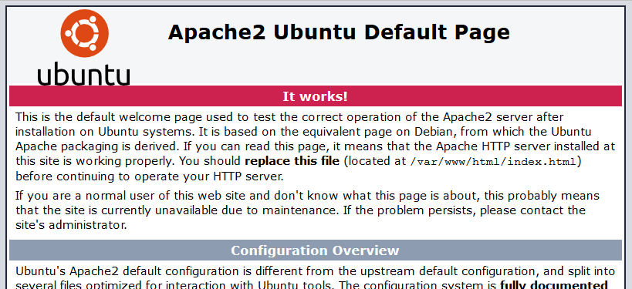
This will show you the default apache web page with some instructions written on it like the one shown below.

Installing MySQL
Installing MySQL server will give you capability to store your data in organized manner. MySQL is a relational database management system. To installing MySQL run the following command.
sudo apt-get install mysql-server php5-mysql
It will ask you if you want to continue the installation, hit y and enter. Then it will also ask you to set a root password for MySQL, Enter your desired password.
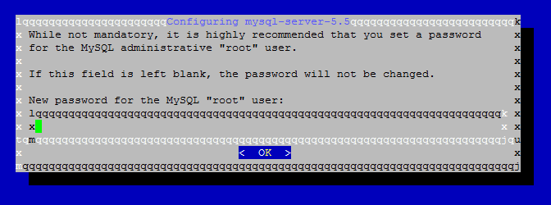
After installing the MySQL server you can start the database server a by issuing the followingcommands.
sudo service mysql start
This will run your MySQL server.
You must not confuse with root passwords of Ubuntu server and MySQL server. Both passwords are different. When you are asked for root password of Ubuntu, you must enter the password assigned to root account of your server. When you are asked for root password of MySQL server, you must enter the password you created when installing MySQL server.

Installing PHP
Apache can only serve static pages, PHP is used to enhance web pages. PHP is most widely used scripting language. Installing PHP will make Apache to process the PHP code with PHP compiler before serving them. You can install PHP by issuing following command.
sudo apt-get install php5 libapache2-mod-php5
This command will install PHP. libapache2-mod-php5 package provides php for Apache2. In order to use PHP with Apache server we will need to restart the server by issuing the following command.
sudo service apache2 restart
You can also install PHP modules by issuing following command.
sudo apt-get install
For example if you want to install three modules at a time which are php5-curl, php5-fpm and php5-cli, you can run the following command.
sudo apt-get install php5-curl php5-fpm php5-cli
This should install the PHP packages without any error. After installing PHP modules you will again need to restart your server.
vim sudo rm /var/www/html/php.php

You can verify PHP installation by creating a php file with phpinfo();
gedit /var/www/html/phpexample.php
<?php
phpinfo();
?>
function. This function will display all the information about PHP processor and all the installed modules of PHP. Execute the following command to create a PHP file using VIM editor inside the Web root directory.
After putting these lines quit from VIM editor with writing the changes into php.php file. Finally you can view the PHP information by browsing this file through web browser, if Public IP of your VPS is 164.31.0.40, then go to the following address.

http://localhost/ phpexample.php
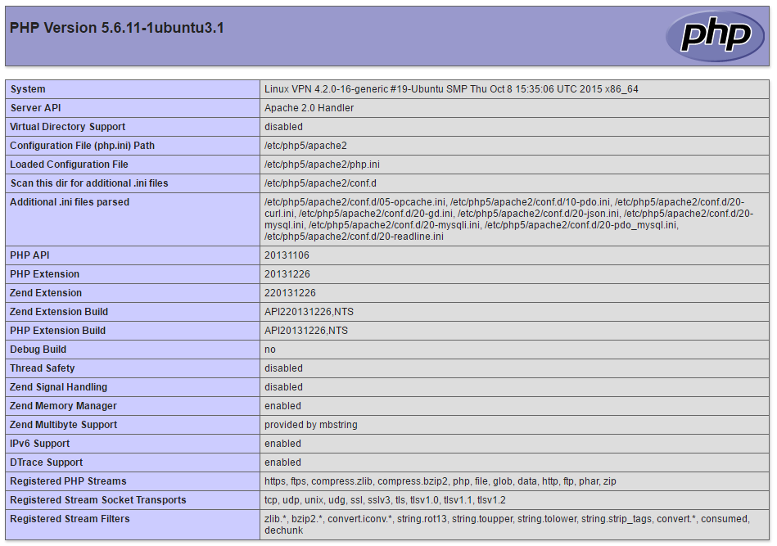
It should show you all the information about PHP like the screenshot attached.

Installing phpMyAdmin
phpMyAdmin provides a graphical user interface to manage MySQL databases and data inside them. You can also run a custom query through phpMyAdmin. This also gives you capability to create, drop or manage privileges of any databases. You can also export or import the data through phpMyAdmin interface. To install phpMyAdmin use the following command.
sudo apt-get install phpmyadmin
It will ask you if you want to continue with the installation, press Y and hit enter to proceed with the installation.
After that it will ask you to select your webserver so that it can configure the server automatically. Select Apache2 by pressing spacebar key and then pressing enter key to proceed. Then It will ask you to use dbconfig-common to setup the database, select yes. Next it will ask you provide a password for phpMyAdmin, you can create any password. Finally it will ask you database administrator password, please enter your database's root password here, which we had created during MySQL installation.
This will successfully install phpMyAdmin, finally restart the Apache web server by issuing the following command.
sudo service apache2 restart
Finally you can access your phpMyAdmin at the following address.
http://phpMyAdmin
For example if you have a VPS with IP address 164.31.0.40then go to the following address to access your phpMyAdmin.
http://164.31.0.40/phpMyAdmin
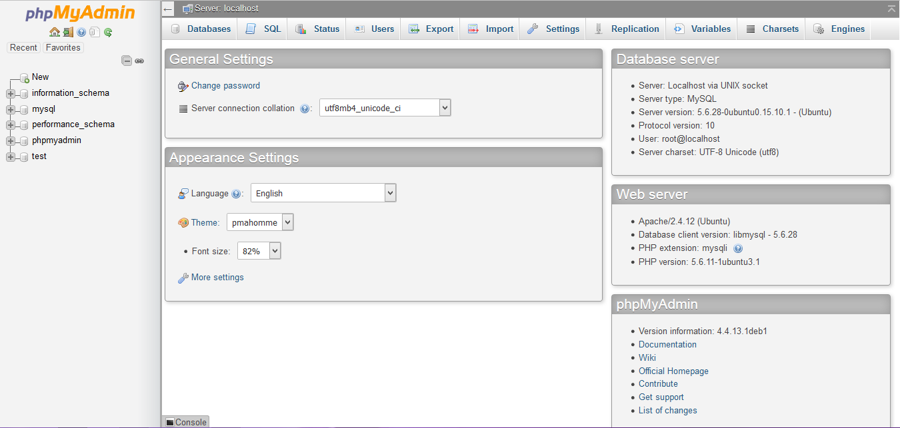
Now you can login to phpMyAdmin using the username root password you have created at

EXPERIMENT: 1. Write code in HTML5 to develop simple webpage.

SOURCE CODE:
<!DOCTYPE html>
<html lang="en">
<head>
<title>My Personal website</title>
<meta charset="utf-8">
<meta name="viewport" content="width=device-width, initial-scale=1">
<link rel="style sheet" href="https://maxcdn.bootstrapcdn.com/bootstrap/3.4.1/css/bootstrap min.css">
<script src="https://ajax.googleapis.com/ajax/libs/jquery/3.5.1/jquery.min.js"></script>
<script src="https://maxcdn.bootstrapcdn.com/bootstrap/3.4.1/js/bootstrap.min.js"></script>
</head>
<body>

<div class="jumbotron text-center">
<h1>My(Write your Name) First Web Page</h1>
<p>Your tagline </p>
</div>

<div class="container">
<div class="row">
<div class="col-sm-4">
<h3>Column 1 (Add your content)</h3>
<p>Lorem ipsum dolor sit amet, consectetur adipisicing elit...</p>
<p>Ut enim ad minim veniam, quis nostrud exercitation ullamco laboris...</p>
</div>
<div class="col-sm-4">
<h3>Column 2 (Add your content)</h3>
<p>Lorem ipsum dolor sit amet, consectetur adipisicing elit...</p>
<p>Ut enim ad minim veniam, quis nostrud exercitation ullamco laboris...</p>
</div>
<div class="col-sm-4">
<h3>Column 3 (Add your content) </h3>
<p>Lorem ipsum dolor sit amet, consectetur adipisicing elit...</p>
<p>Ut enim ad minim veniam, quis nostrud exercitation ullamco laboris...</p>
</div>
</div>
</div>
</body>
</html>

OUTPUT:

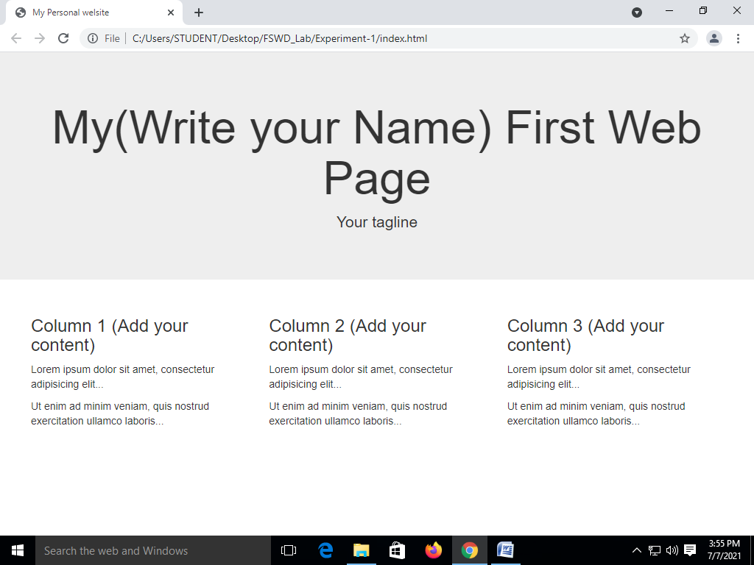

EXPERIMENT 2: Write CSS5 & HTML5 Code to show Dropdown Menu.

SOURCE CODE:
<!DOCTYPE html>
<html lang="en">
<head>
<title>My Personal welsite</title>
<meta charset="utf-8">
<meta name="viewport" content="width=device-width, initial-scale=1">
<linkrel="stylesheet"href="https://maxcdn.bootstrapcdn.com/bootstrap/3.4.1/css/bootstrap.min.css">
<script src="https://ajax.googleapis.com/ajax/libs/jquery/3.5.1/jquery.min.js"></script>
<script src="https://maxcdn.bootstrapcdn.com/bootstrap/3.4.1/js/bootstrap.min.js"></script>
</head>
<body>
<nav class="navbar navbar-inverse">
<div class="container-fluid">
<div class="navbar-header">
<button type="button" class="navbar-toggle" data-toggle="collapse" data- target="#myNavbar">
<span class="icon-bar"></span>
<span class="icon-bar"></span>
<span class="icon-bar"></span>
</button>
<a class="navbar-brand" href="#">WebSiteName</a>
</div>
<div class="collapse navbar-collapse" id="myNavbar">
<ul class="nav navbar-nav">
<li class="active"><a routerLink="/Home">Home</a></li>
<li class="dropdown">
<a class="dropdown-toggle" data-toggle="dropdown" href="#">Page 1 <span class="caret"></span></a>
<ul class="dropdown-menu">
<li><a href="#">Page 1-1</a></li>
<li><a href="#">Page 1-2</a></li>
<li><a href="#">Page 1-3</a></li>
</ul>
</li>
<li><a href="#">Page 2</a></li>
<li><a routerLink="/About" >About</a></li>
</ul>
<ul class="nav navbar-nav navbar-right">
<li><a href="#"><span class="glyphicon glyphicon-user"></span> Sign Up</a></li>
<li><a href="#"><span class="glyphicon glyphicon-log-in"></span> Login</a></li>
</ul>
</div>
</div>
</nav>
</body>
</html>

OUTPUT:

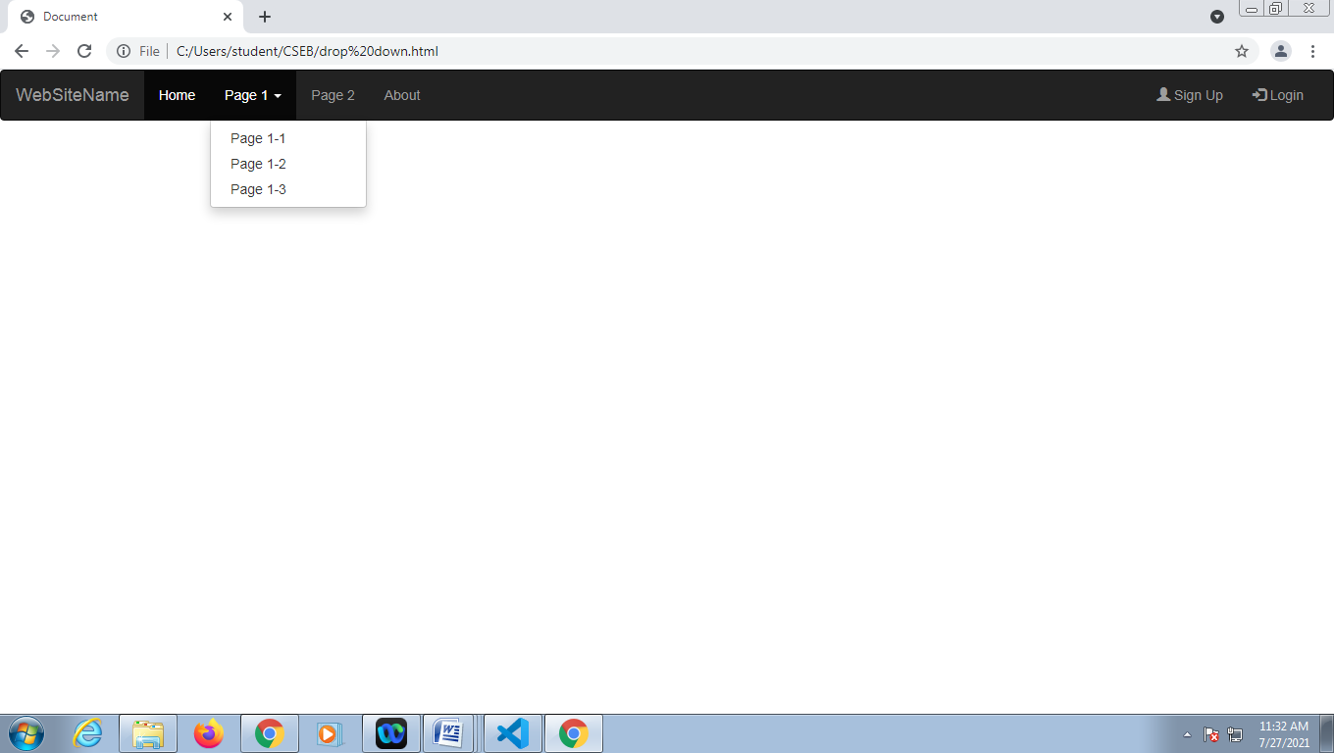

EXPERIMENT 3: Write HTML5, CSS and JavaScript code to Create one-page website having different menu items.

SOURCE CODE:

    - npm install -g @angular/cli
    - ng new my-app
    - cd my-app
    - ng serve –open

Opens your browser to http://localhost:4200/

app.component.html

<app-navbar></app-navbar>
<router-outlet></router-outlet>

home.component.html

<p>home works!</p>
<h1>Lorem ipsum, dolor sit amet consectetur adipisicing elit. Rerum, ad? Neque ducimus repellendus enim veniam vel magnam perspiciatis fugit nesciunt?</h1>
<h2>Lorem ipsum dolor sit amet consectetur adipisicing elit. In, aperiam.</h2>

about.component.html

<h1>about works!</h1>
<p>Lorem ipsum dolor sit, amet consectetur adipisicing elit. Consectetur ab natus aperiam, saepe accusantium voluptas dolo</p>

app-routing.module.ts

const routes: Routes = [
{ path: 'Home', component: HomeComponent },
{ path: 'About', component: AboutComponent },
];

OUTPUT:


EXPERIMENT 4: Write a program in CSS to show your city with building and moving cars.

SOURCE CODE:
Index.html
<!DOCTYPE html>
<html lang="en">
<head>
<meta charset="UTF-8">
<meta http-equiv="X-UA-Compatible" content="IE=edge">
<meta name="viewport" content="width=device-width, initial-scale=1.0">
<title>Moving Cars</title>
<link rel="stylesheet" href="./style.css">
</head>

<body>
<div class="moon"></div>

<div class="skyline">
<div class="building1-shadow"></div>
<div class="building1">

<div class="building-left-half"></div>
<div class="building-right-half"></div>
</div>
</div>
<div class="road">
<div class="road-top-half"></div>
<div class="road-bottom-half"></div>
</div>
<divclass="car-container">
<div class="car-top1">
<div class="window1"></div>
<div class="window2"></div>

</div>
<div class="car-top2">
<div class="door">
<div class="door-knob"></div>
</div>
</div>
<div class="car-bottom">
<div class="wheel1-top"></div>
<div class="wheel1">
<div class="wheel-dot1"></div>
<div class="wheel-dot2"></div>
<div class="wheel-dot3"></div>
<div class="wheel-dot4"></div>
</div>
<div class="wheel2-top"></div>
<div class="wheel2">
<div class="wheel-dot1"></div>
<div class="wheel-dot2"></div>
<div class="wheel-dot3"></div>
<div class="wheel-dot4"></div>
</div>
</div>
</div>
</body>
</html>

style.css
{
box-sizing: border-box;
}
*,
*:before,
*:after {
box-sizing: inherit;
}
body {
overflow: hidden;
height: 100vh;
background: linear-gradient(180deg, #09283d, #1b415c, #29516c, #6e8ea5, #7cadd0, #7cadd0, #7cadd0, #7cadd0, #6e8ea5, #3a6583, #1a4461, #09283d);
background-size: 2400% 2400%;
animation: dayNight 60s ease infinite;
}

@keyframes dayNight { 0%{background-position:25% 0%}
50%{background-position:76% 100%}
100%{background-position:25% 0%}
}
@keyframes driving {
0% {
left: -25%;
}
10% {
bottom: 0%;
}

20% {
transform:scale(0.5)
rotateZ(-5deg);
bottom: 5%
}
25% {
transform: scale(0.5) rotateZ(0deg);
}

40% {
transform: scale(0.5) rotateZ(5deg);
}
50% {
transform: scale(0.5) rotateZ(0deg);
}
100% {
left: 110%;
bottom: 10%;
transform: scale(0.5) rotateZ(0deg);
}
}

@keyframes road-moving {
100% {
transform: translate(-2400px);
}
}
@keyframes wheels Rotation {
100% {
transform: rotate(360deg);
}
}
@keyframes moon {
50% {
transform: translateY(-20px);
}
100% {
transform: translate(80px, -140px);
}
}
@keyframes sun-moon {
from { transform:rotate(0deg); }

to {transform:rotate(360deg); }
}
/* CAR CONTAINER */
.car-container {
position: absolute;
bottom: -10%;
width: 430px;
height: 300px;
animation: driving 5s infinite linear;
transform: scale(0.5);
}
.car-container:after {
content: "";
width: 426px;
height: 1px;
margin-top: 88px;
display: block;
position: absolute;
left: -3%;
z-index: -1;
bottom: 0;
box-shadow: 2px -15px 25px 2px #000000;
}
/* WHEELS */
.wheel1,
.wheel2 {
width:120px;
height: 120px;
background-color: grey;
border-radius: 50%;
border: 20px solid black;
position: absolute;
bottom: 0;
animation: wheelsRotation 1s infinite linear;
}

.wheel1 {
left:5%
}
.wheel1-top,
.wheel2-top
{
bottom: 48px;
position: absolute;
width: 106px;
height: 80px;
border-radius: 50%;
z-index: 5;
box-shadow: 0px 13px 3px 0px rgba(240, 240, 240, 0.53);
transform: rotateX(180deg);
}
}
.wheel1-top{
left:7%
}
.wheel1-top{
right:5%
}
.wheel2{
right:5%
}
.wheel-dot1,
.wheel-dot2
{
width: 10px; height: 25px;
background-color: black;
position: absolute;
}
.wheel-dot3,
.wheel-dot4 {
width: 25px; height: 10px;
background-color: black;
position: absolute;
}
wheel-dot1 {
top: 10%;
left: 45%;
}
.wheel-dot2 {
bottom: 10%;
left: 45%;
}
.wheel-dot3 {
top: 45%;
right: 10%;
}
.wheel-dot4 {
top: 45%;
left: 10%;
}
.door {
width: 110px;
height: 100px;
border: 3px solid #B57A84; position: absolute;
left: 36%;
top: 16px;
border-radius: 10% 40% 10% 10%;
}
.door-knob {
width: 30px;
height: 14px;
background-color: #E8E6E6; border-radius: 30%;
position: absolute;
left: 20%;
top: 5%;
border: 1px solid lightcoral;
}
.car-top1 {
border-radius: 25% 40% 0 0;
background color: #6A1621;
max-width: 100%;
width: 250px;
height: 130px;
position: absolute;
top: 0;
left: 4%;
}
.window1,
.window2 {
background-color: #E2F0F6;
border-radius: 5px;
position: absolute;
width: 40%;
height: 60%;
margin: 17px;
border: 9px solid #BF6D7B;
}
.window1 {
left: 0;
border-top-left-radius: 30%;
}
.window2 {
right: 0;
border-top-right-radius: 50%;
}
.car-top2 {border-radius: 100px 200px 0 0;
background-color: #25659C;
*/ border: 10px solid #72252F;
background-color: #9C2535;
max-width: 100%;
width: 430px;
height: 140px;
position: absolute;
bottom: 20%;
}
.road {
width: 250%;
height: 200px;
background-color: #585858;
border-top: 10px solid #756D6D;
border-bottom: 20px solid #756D6D;
position: absolute;
bottom: 0%;
margin-left: -10px;
padding: 0;
}
.road::before {
content: " ";
position: absolute;
z-index: 0;
top: -17px;
left: 0px;
right: 0px;
border: 5px solid black;
}
.road-top-half {
height: 15px;
width: 250%;
position: absolute;
left: -10%;
top: 30px;
border-top: 40px dashed white;
margin-top: 25px;
animation: road-moving 10s infinite linear;
transition: all 3s linear;
}
.skyline { width: 100%;
position: absolute;
bottom: 205px;
padding: 0;
left: 110%;
animation: road-moving 10s infinite linear;
transition: all 8s linear;
}
.building1 {
width: 220px; height: 450px;
background-color: #211919;
position: relative;
}
.building1-shadow {
border-top: 15px solid transparent; border-right: 60px solid rgb(44, 37, 37); border-bottom:15px solid#000;
border-left:15px solidtransparent; height: 450px;
width:200px; position:absolute; left: -199px;
}
.building-left-half,
.building-right-half {
height: 300px;
width: 50px;
position: absolute;
top: 10px;
border-left: 16px dashed #A9D2C7;
border-right: 16px dashed rgba(255, 255, 0, 0.19);
margin-top: 25px;
}
.building-left-half {
left: 10px; padding: 25px;
}
.building-right-half {
right: 10px;
padding: 20px;
}
.moon {
height: 100px;
width: 100px;
border-radius: 50%;
background: rgb(207, 207, 212);
margin: auto;
box-shadow: 0 0 60px gold, 0 0 100px rgb(185, 160, 24), inset 0 5px 12px 26px #F5F5F5, inset -2px 8px 15px 36px #E6E6DB;
transition: 1s;
transition: 1s;
right:370px;
top: 30px;
position: absolute;
animation: sun-moon 40s 2s linear infinite;
transform-origin: 50% 500px;
}
/*Headlights*/
.car-top1:after
{
width: 13px;
height: 37px;
background-color: #BACCDA;
position: absolute;
bottom: -63px;
right: -168px;
z-index: 10;
content: " ";border-radius: 10px;
border: 2px solid black;
border-left-style: none; transform: rotate(-15deg);
}
.car-top2:after
{
position: absolute;
bottom: 7px;
right: -340px;
content: " ";
width: 0;
height: 0;
border-top: 20px solid transparent;
border-bottom: 80px solid transparent;
border-right: 500px solid rgba(191,188,87,0.7);
z-index: -1;
-webkit-mask-box-image: -webkit-linear-gradient(left, black, transparent);
-webkit-mask-box-image: -o-linear-gradient(left, black, transparent);
-webkit-mask-box-image:linear-gradient(to right, black, transparent);
transform: rotate(-9deg);
}

OUTPUT:
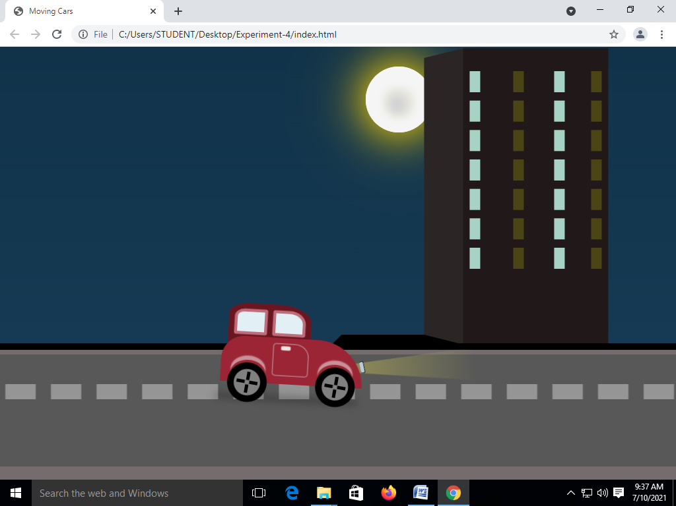

EXPERIMENT 5: Write a program to validate web form using JavaScript.
SOURCE CODE:
Register.pug

doctypehtml
html(lang="en")
Head
meta(charset="UTF-8")
meta(http-equiv="X-UA-Compatible", content="IE=edge")
meta(name="viewport", content="width=device-width, initial-scale=1.0")
title Register
style
include ./my.css
body
div(class='container')
include ./index.pug
h1 Registration form
ul(id="errors")
Br
form(action="/Register" method="post" align="center")
label(for="username") username
input(type="text" name="username")
Br
Br
label(for="password") password
input(type="password" name="password")
Br
label(for="cpassword") Confirm password
input(type="password" name="cpassword")
Br
Br
label(for="age") user age
input(type="text" name="age")
Br
Br
label(for="mobile") user mobile
input(type="text" name="mobile")
Br
label(for="email") user email
input(type="text" name="email")
Br
Br
input(type="submit" name="Register" value="Register")

App.js

Const
express=require('express’);
const bodyparser=require("body-parser") const bcrypt=require("bcrypt");
const user=require('./models/user'); const mongoose = require('mongoose');
const expressValidator = require("express-validator");
const {check, validationResult} = require('express-validator/check') const app = express();
const port = process.env.PORT || 80 mongoose.connect("mongodb://localhost:27017/user",{userNewUrlParser : true}); app.set('view engine', 'pug');
app.use(bodyparser.json()); app.use(bodyparser.urlencoded({extended:true}));
//handling get request app.get('/',function(req,res){ res.render('index')
})
app.get('/Register', function(req,res){

res.render('Register')
})
//handling post request
app.post('/Register', [
check('username').not().isEmpty().isLength({min:5}).withMessage('User name must be 5 characters'), check('password').not().isEmpty().isLength({min:6}).withMessage('Password name must be 6
characters'),
check('mobile').not().isEmpty().isInt().isLength({min:10}).withMessage('mobile number must be
number and 10 characters'),
check('cpassword').custom((value,{req}) => (value === req.body.password)).withMessage("Confirm password not match with your password"),
check('email').not().isEmpty().isEmail().normalizeEmail().withMessage("Enetr proper email"),
],
function(req,res){
const errors= validationResult(req);
if(!errors.isEmpty())
{
return res.status(422).jsonp(errors.array());
}
else{
//console.log(req.body.username) const newUser=new user();
newUser.username=req.body.username;
var salt=bcrypt.genSaltSync(10);
varhash=bcrypt.hashSync(req.body.password,salt);
newUser.password=hash;
newUser.age=req.body.age;
newUser.mobile=req.body.mobile;
newUser.save(function(err,result){
if(err){
console.log(err);
}
else{
console.log(result); res.redirect("Login");
}

})

}
})

})

app. listen(port,() => {console.log(`app is listening on http://localhost:${port}`)})

Model/users.js

Const mongoose=require('mongoose');
const Schema=mongoose. Schema;
const user Schema=new Schema(
{
username : {type: String},
password : {type: String},
age : {type: Number},
mobile : {type: Number}
}
);
module.exports=mongoose. model("user",userSchema);

OUTPUT:

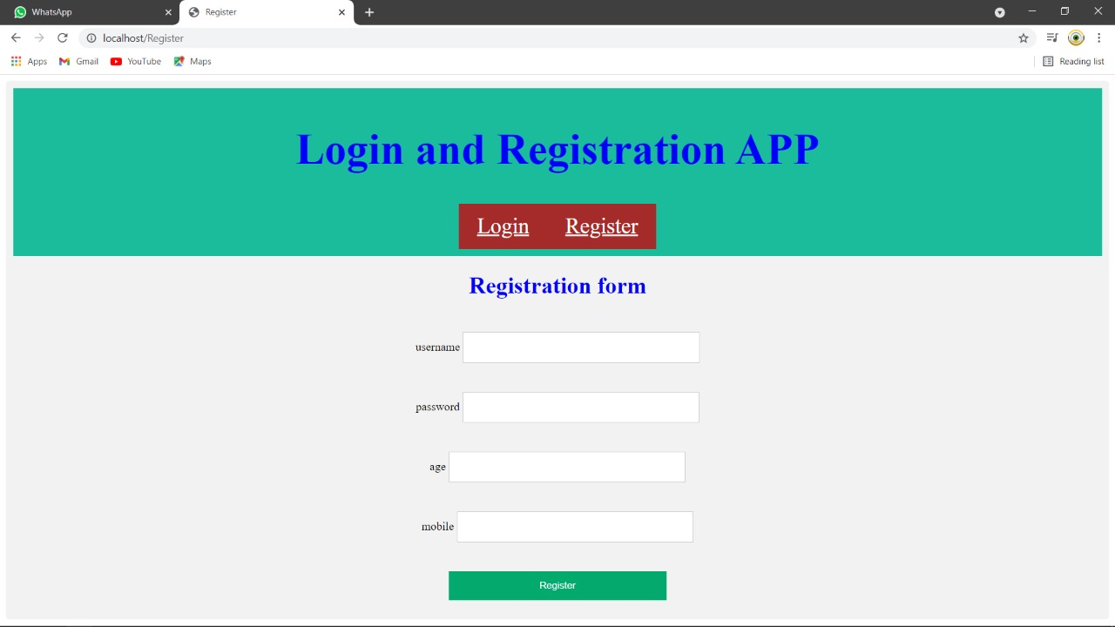

EXPERIMENT 6: Write jquery code to show website slider.

SOURCE CODE:
Corousel.html:

<!DOCTYPE html>
<html lang="en">
<head>
<title>JQuery Slider</title>
<meta charset="utf-8">
<meta name="viewport" content="width=device-width, initial-scale=1">
<link rel="stylesheet"href="https://maxcdn.bootstrapcdn.com/bootstrap/3.4.1/css/bootstrap min.css">
<script src="https://ajax.googleapis.com/ajax/libs/jquery/3.5.1/jquery.min.js"></script>
<script src="https://maxcdn.bootstrapcdn.com/bootstrap/3.4.1/js/bootstrap.min.js"></script>
</head>
<body>
<div class="container">
<div id="myCarousel" class="carousel slide">
<ol class="carousel-indicators">
<li class="item1 active"></li>
<li class="item2"></li>
<li class="item3"></li>
</ol>
<div class="carousel-inner" role="listbox">
<div class="item active">
<img src="1.jpg" alt="image1" width="100%" height="100%">
</div>
<div class="item">
<img src="2.jpg" alt="image2" width="100%" height="100%">
</div>
<div class="item">
<img src="3.jpg" alt="image3" width="100%" height="100%">
</div>

</div>
<a class="left carousel-control" href="#myCarousel" role="button">
<span class="glyphicon glyphicon-chevron-left" aria-
hidden="true"></span>
<span class="sr-only">Prev</span>
</a>
<a class="right carousel-control" href="#myCarousel" role="button">
<span class="glyphicon glyphicon-chevron-right" aria-
hidden="true"></span>
<span class="sr-only">Next</span>
</a>
</div>
</div>
<script>
$(document).ready(function(){
$("#myCarousel").carousel();
$(".item1").click(function(){
$("#myCarousel").carousel(0);
})
$(".item2").click(function(){
$("#myCarousel").carousel(1);
})
$(".item3").click(function(){
$("#myCarousel").carousel(2);
})
$(".left").click(function(){
$("#myCarousel").carousel("prev");
})
$(".right").click(function(){
$("#myCarousel").carousel("next");
})
});
</script>
</body>
</html>

OUTPUT:

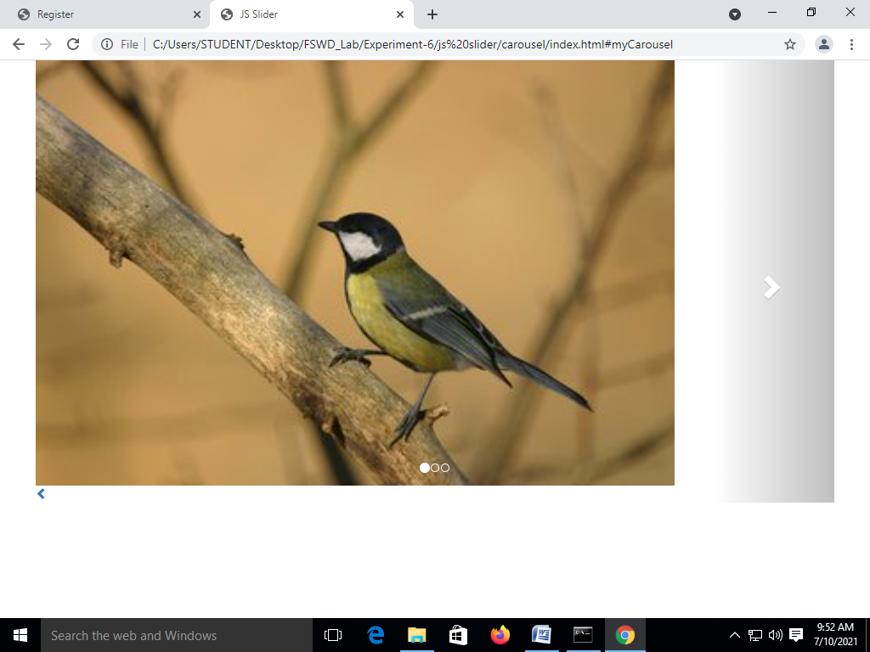

EXPERIMENT 7: Show version control in Github.

$ git config --global user.name "cmr"
$ git config --global user.email cmr@example.com

Index.html
<h1>welcome to my web page</h1>
git init git add .
git commit -m "Hello world"

Index.html
<h1>welcome to my web page</h1>
<p>My first website</p>

git add .
git commit -m "paragraph added"
git log git staus

git branch -M main
git remote add origin url git push -u origin main

OUTPUT:
EXPERIMENT 8: Write a program in JavaScript to create a user login system.

Login.pug:

doctypehtml
html(lang="en")
head
meta(charset="UTF-8")
meta(http-equiv="X-UA-Compatible", content="IE=edge")
meta(name="viewport", content="width=device-width, initial-scale=1.0")
title Login
style
include ./my.css
body
div(class='container')
include ./index.pug
h1 Login form
br
form(action="/Login" method="post" align="center")
label(for="username") username
input(type="text" name="username")
br
br
label(for="password") password
input(type="password" name="password")
br
br
input(type="submit" name="Login" value="Login")

Style.css

h1{
color:blue;
text-align:center;
}
a:link,a:visited{
background-color: brown;
color:white;
padding:14px 25px;
text-align: center;
display: inline-block;
}
a:hover,a:active{
background-color: chartreuse;
}
.header {
padding: 10px;
text-align: center;
background: #1abc9c;
color: white;
font-size: 30px;
}
.container {
border-radius: 5px;
background-color: #f2f2f2;
padding: 10px;
}
input{
width: 20%;
padding: 12px;
border: 1px solid #ccc;
margin-top: 6px;
margin-bottom: 16px;
resize: vertical;
}
input[type=submit] {
background-color: #04AA6D;
color: white;
padding: 12px 20px;
border: none;
cursor: pointer;
}
input[type=submit]:hover {
background-color: #45a049;
}
label{
color: blue;
font-size: 22px;
padding: 8px;
text-align:left;
}

App.js
Const express=require('express');
const bodyparser=require("body-parser")
const bcrypt=require("bcrypt");
const user=require('./models/user');
const mongoose = require('mongoose');
const expressValidator = require("express-validator");
const {check, validationResult} = require('express-validator/check')
const app = express();
const port = process.env.PORT || 80
mongoose.connect("mongodb://localhost:27017/user",{userNewUrlP
arser : true});
app.set('view engine', 'pug');
app.use(bodyparser.json());
app.use(bodyparser.urlencoded({extended:true}));
//handling get request
app.get('/',function(req,res){
res.render('index')
})
app.get('/Login',function(req,res){
res.render('Login')
})
//handling post request
app.post('/Login',function(req,res){
user.findOne({username:req.body.username},function(err,docs){
if(err)
{
console.log(err)
}
else

{
if(docs.username==req.body.username)
{
bcrypt.compare(req.body.password,docs.password,function(err,data)
{
if(err)
{
console.log(err);
}
if(data)
{
console.log(data);
res.send("Welcome");
}
else
{
res.send("invalid password");
}
});
}
else
{
//res.send("invalid username or password")
res.redirect("Register");
}
}
})
})
app.listen(port,() => {console.log(`app is listening on http://localhost:${port}`)})

Models/user.js
const mongoose=require('mongoose');
const Schema=mongoose.Schema;

const userSchema=new Schema(
{
username : {type:String},
password : {type:String},
age : {type:Number},
mobile : {type:Number}
}
);
module.exports=mongoose.model("user",userSchema);

OUTPUT:

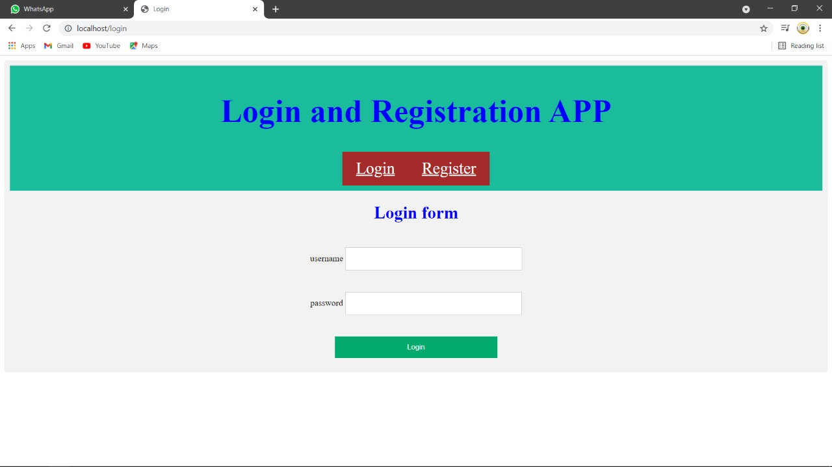

Welcome

EXPERIMENT 9: Create a website showing jquery slider.
<!DOCTYPE html>
<html lang="en">
<head>
<meta charset="UTF-8">
<meta http-equiv="X-UA-Compatible" content="IE=edge">
<meta name="viewport" content="width=device-width, initial-scale=1.0">
<title>JS Slider</title>
<link rel="stylesheet"
href="https://maxcdn.bootstrapcdn.com/bootstrap/3.4.1/css/bootstrap.min.css">
<script>
src="https://ajax.googleapis.com/ajax/libs/jquery/3.5.1/jquery.min.js"></script>
<script>
src="https://maxcdn.bootstrapcdn.com/bootstrap/3.4.1/js/bootstrap.min.js"></script>
</head>
<body>
<nav class="navbar navbar-inverse">
<div class="container-fluid">
<div class="navbar-header">
<button type="button" class="navbar-toggle" data-toggle="collapse"
data-target="#myNavbar">
<span class="icon-bar"></span>
<span class="icon-bar"></span>
<span class="icon-bar"></span>
</button>
<a class="navbar-brand" href="#">WebSiteName</a>
</div>
<div class="collapse navbar-collapse" id="myNavbar">
<ul class="nav navbar-nav">
<li class="active"><a routerLink="/Home">Home</a></li>
<li class="dropdown">
<a class="dropdown-toggle" data-toggle="dropdown" href="#">Page 1
<span class="caret"></span></a>
<ul class="dropdown-menu">
<li><a href="#">Page 1-1</a></li>
<li><a href="#">Page 1-2</a></li>
<li><a href="#">Page 1-3</a></li>
</li>
<li><a href="#">Page 2</a></li>
<li><a routerLink="/About" >About</a></li>
</ul>
<ul class="nav navbar-nav navbar-right">
<li><a href="#"><span class="glyphicon glyphicon-user"></span> SignUp</a></li>
<li><a href="login.html"><span class="glyphicon glyphicon-log-in"></span> Login</a></li>
</ul>
</div>
</div>
</nav>
<div class="container">
<div id="myCarousel" class="carousel slide">
<ol class="carousel-indicators">
<li class="item1 active"></li>
<li class="item2"></li>
<li class="item3"></li>
</ol>
<div class="carousel-inner" role="listbox">
<div class="item active">
<img src="1.jpg" alt="image1" width="100%" height="100%">
</div>
<div class="item">
<img src="2.jpg" alt="image2" width="100%" height="100%">
</div>
<div class="item">
<img src="3.jpg" alt="image3" width="100%" height="100%">
</div>
</div>
<a class="left carousel-control" href="#myCarousel" role="button">
<span class="glyphicon glyphicon-chevron-left" aria-hidden="true"></span>
<span class="sr-only">Prev</span>
</a>
<a class="right carousel-control" href="#myCarousel" role="button">
hidden="true"></span>
<span class="sr-only">Next</span>
</a>
</div>
</div>
<script>
$(document).ready(function(){
$("#myCarousel").carousel();
$(".item1").click(function(){
$("#myCarousel").carousel(0);
})
$(".item2").click(function(){
$("#myCarousel").carousel(1);
})
$(".item3").click(function(){
$("#myCarousel").carousel(2);
})
$(".left").click(function(){
$("#myCarousel").carousel("prev");
})
$(".right").click(function(){
$("#myCarousel").carousel("next");
})
});
</script>
</body>
</html>

OUTPUT:

EXPERIMENT 10: Write a program to show user details using HTML, CSS, & AJAX.

Ajax.pug:

doctype html
html(lang"en")
head
meta(charset="UTF-8")
meta(http-equiv="X-UA-Compatible",content="IE=edge") meta(name="viewport",content="width=device-width,initial-scale=1.0")
title Login
style
include./my.css script(src="http://code.jquery.com/jquery-3.1.0.min.js") script(src="/magic.js")
include ./index.pug body
div(class='container')
form(method="post" id="change" align="center") input(type='text', placeholder='search user', name='name') input(type="submit", value="Search")
br
h1 User Details p !{name}

/public/magic.js

$(document).ready(function(){
$("form#change").on('submit',function(e)
{
e.preventDefault();
var data = $('input[name=name]').val();
$.ajax({
type: 'post',
url: '/ajax',
data:data, dataType: 'text'
})
.done(function(data){
$('h1').html(data.name);
});
});
});
App.js
const express = require('express');
const bodyparser=require("body-parser")
const bcrypt=require("bcrypt");
const user=require('./models/user');
const mongoose=require('mongoose');
const expressValidator = require("express-validator");
const {check, validationResult} = require('express-validator/check')
const app = express();
const port = process.env.PORT || 80
mongoose.connect("mongodb://localhost:27017/user",{userNewUrlParser : true}); app.set('view engine', 'pug');
app.use(bodyparser.json()); app.use(bodyparser.urlencoded({extended:true});
app.get('/ajax', function(req, res){
res.render('ajax', {title: 'An Ajax Search', name: "Search user!"});
});

app.post('/ajax', function(req, res){
user.findOne({username:req.body.name},function(err,docs)
{
if(err)
{
console.log(err)

}
else
{

res.render('ajax', {title: 'An Ajax search', name: "Name "+docs.username+", Age "+docs.age+", Mobile "+docs.mobile });

}

});
});

app.listen(port,() => {console.log(`app is listening on http://localhost:${port}`)})

OUTPUT:

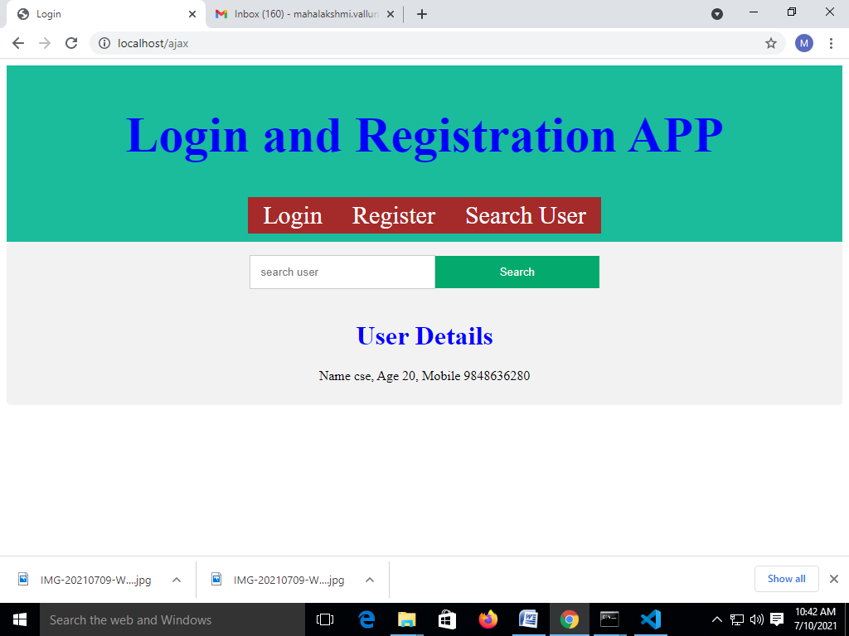

EXPERIMENT 11: Write a program to display options in a search engine using Ajax.
Ajax.pug:
doctype html
html(lang"en")
head
meta(charset="UTF-8")
meta(http-equiv="X-UA-Compatible", content="IE=edge")
meta(name="viewport", content="width=device-width, initial-scale=1.0")
title Login
style
include ./my.css
script(src="http://code.jquery.com/jquery-3.1.0.min.js")
script(src="/magic.js")
include ./index.pug
body
div(class='container')
form(method="post" id="change" align="center")
input(type='text', placeholder='search user', name='name')
input(type="submit", value="Search")
br
a(href="") All
a(href="") images
a(href="") Latest
a(href="") News
h1 User Details
p !{name}

/public/magic.js

$(document).ready(function(){
$("form#change").on('submit', function(e){
e.preventDefault();
var data = $('input[name=name]').val();
$.ajax({
type: 'post',
url: '/ajax',
data: data,
dataType: 'text'
})
.done(function(data){
$('h1').html(data.name);
});
});
});

OUTPUT:

